Name: Kyle Choi

Removing unused pages from the template

Some visualizations are better viewed in a landscape orientation rather than portrait. There are four pages following this page: 2 pages in landscape layout and 2 pages are in portrait layout.

How to remove unwanted pages (without altering the template layout):

* From the Home Tab, locate the Hide/Show paragraph marks button 
* Click the Hide/Show paragraph marks button to see all of the formatting symbols.
* This will allow you to see page breaks and other spacing symbols.
* Navigate to the page you want to delete
* Select the text (page) you want to remove and delete it. Pay attention to the text that follows to make sure you maintain the layout after deleting the unwanted pages.
* Click the Hide/Show paragraph marks button again to Hide the formatting symbols.

**Exercise3:** Practice removing unwanted pages.

Locate the two pages (below) with instructions to “Remove this page” and remove the pages from this document. Make sure you keep the layout of the remaining pages.

**Save the resulting file as: LastnameFirstInitial_CGT270Lab0_Exercise3.pdf.**

This page layout is **landscape Keep this page.**



This page layout is **landscape** Keep this page.

**Most Common Language in U.S. States (Excl. English or Spanish)**

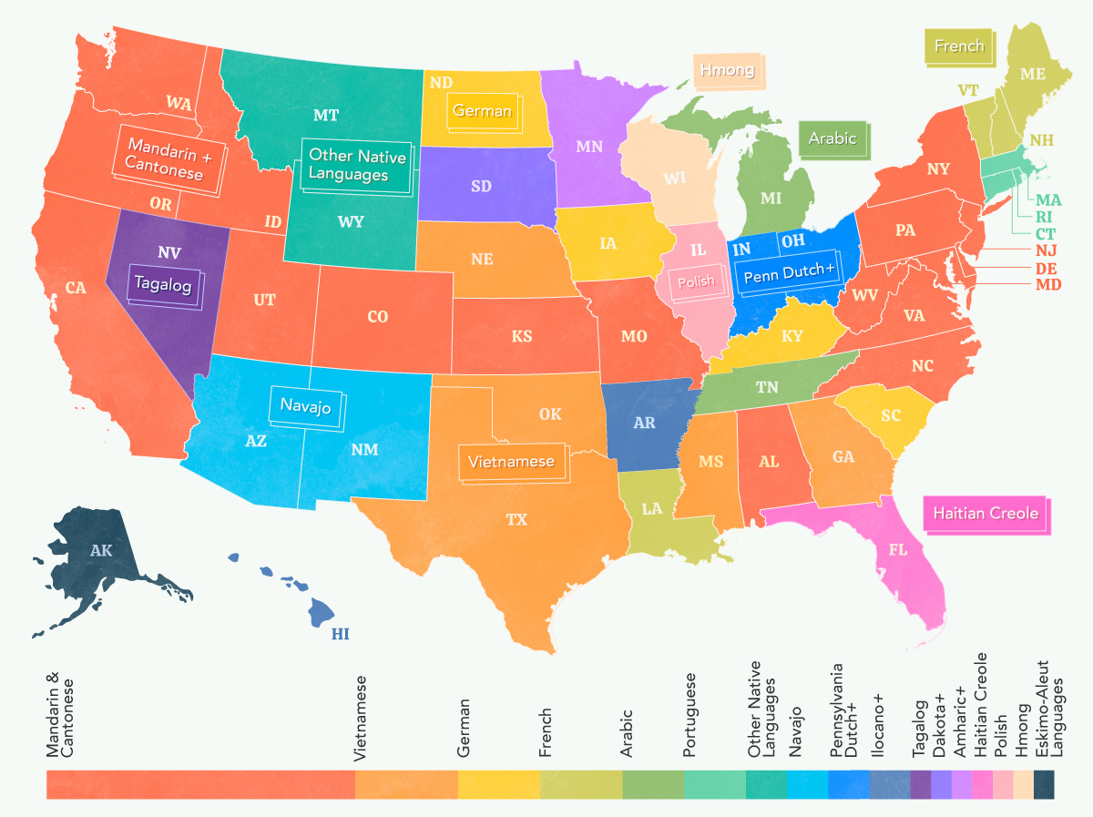

This page layout is **portrait**. Keep this page.

## All the Biomass of Earth, in One Graphic

